**Engagement May 2016 – July 2016**

The purpose of this document is to advise the TPS Pension Board of recent key activity on engagement with scheme members and employers so as to assist the Board in its assurance role - in particular in the area of communicating information to members. The report also aims to assist the Board in its strategic role by providing information on specific actions and projects that aim to ensure the administration continues to improve and best serve all stakeholders’ needs

|  |  |
| --- | --- |
| **Member engagement and campaigns** |  |

There have been key gains in the number of scheme members setting up My Pension Online (MPO) accounts, driven predominantly by the year-end activity around the promotion of P60 and Benefit Statements. Account holder numbers have increased by over 7% (up to 469k registered members) in the quarter.

The period has also seen the successful launch of the Flexibilities calculator, as well as the new website based hub aimed at Newly Qualified Teachers (NQT) (<https://www.teacherspensions.co.uk/campaigns/active/nqt-hub/member/nqt-hub.aspx>). The hub has proved successful, with over 5,600 unique page views since its launch in June. Interest has been predominantly generated from links promoting the site through an active social media campaign which provides useful insight into the preferred engagement channels of the target audience.

Discussions with colleagues from the National College for Teaching and Leadership are also taking place to develop a programme of activity for NQT service providers to better promote an understanding among NQTs of the value and benefits of TP membership.

Feedback data supporting the quality of member engagement has remained positive throughout the period, with outcome measures relating to members’ understanding of the value of the scheme, and evidence of active retirement planning, on track to attain their respective targets at year end.

Directed member email campaigns have performed to expectations throughout the quarter in terms of their open and ‘click through’ rates (CTR).

However there has been mixed success with scheduled auto communications intended to prompt and remind members of actions or events. Although emails to new members welcoming them to the scheme continue to fall slightly short of their target rates, the pre-retirement campaign has consistently missed its CTR by a significant margin. Analysis suggests that as the covering email contains a high level of information, recipients don’t feel the need to continue to follow the links to the web data. The structure of the communication and balance of information is currently under review with the ultimate aim of ensuring members receive the information that is relevant to them and take the actions they need to take as a result.

All other scheduled member communications across the period have achieved their expected targets.

Work continues on P60 communications. In July a pensioner specific Focus Group was delivered to further understand the impact and views of pensioners about the P60 moving online from April 2017, and additionally to ascertain pensioner’s views about the digital agenda. Feedback and recommendations from the research findings will be fed into the P60 project.

Concerns around ‘channel of choice’ when receiving scheme information continue to be considered in all communications – an issue raised in respect of P60 distribution. Currently less than 2,700 members (out of a cohort of 680k pensioner members) have opted to receive a hard copy of their P60 statement as their channel of choice. TP will continue to monitor the position.

The communications regarding the revised Pension Input Period requirements have now been finalised and have been published alongside the Pension Savings Statement.

|  |  |
| --- | --- |
| **Employer engagement and campaigns** |  |

Evidence of employer engagement with the scheme remains strong, with usage of the Employer portal consistent at 90%. Monthly e-bulletins continue to be well received and are consistently hitting their targets for employer engagement.

Work implementing the Monthly Data Collection (MDC) communications and engagement plan continues at pace. Activity to date includes: two targeted email campaigns to employers; implementation of MDC website pages - including clear signposting on the website homepage - and delivery of 18 webinars which have yielded important contact details to allow the dedicated MDC Team to follow up to encourage on-boarding. A second phase of webinars is in train to provide more detailed guidelines for those going through the on-boarding process. In addition to webinars, seminars have also taken place across multiple UK sites and information about MDC remains a prominent feature within monthly Employer Bulletins.

Although the MDC email campaigns have proved of interest to employers with open rates hitting their targets, CTRs have been relatively low. The assumption is that, as the call to action prompt is geared towards employers who are already at the point of signing up for MDC, this is discouraging some recipients from progressing through to the website via the web-link. This will be reviewed.

Of continuing concern is the low level engagement being seen in response to the ‘new employer welcome’ email, which is issued to employers when joining the scheme. Although the low level of new employers currently coming on stream presents a minimal risk (as mitigation arrangements allow for a more resource intensive, short term solution to ensure the employer is aware of their responsibilities to the scheme), identifying more effective ways to engage this cohort is seen as a priority to mitigate any future surge in academy conversion numbers.

The main issue is targeting the relevant contact within the new employer as, at present, there is very limited data available to the scheme regarding new employers (i.e. converting academies). A major review of current process and communication links between TPS (Department and Capita) and academies is about to begin which will address this issue. (See also Paper 12 on Risks for actions here.)

Stakeholder engagement

The latest Teachers’ Pensions Administration Review Group (TPARG) meeting was held on 5 July. Key considerations were shared with the Board in Karen Cammack’s email of 14 July but briefly comprised:

* member representatives highlighted their concerns surrounding the move to online P60s, while at the same time recognising the change of; approach in giving a higher profile to the option to continue to receive paper copies;
* the need for payroll advice to be more prominent in dealing with converting academies;
* the group welcomed the introduction of a revised casework approach to critical ill health and death in service applications; and
* discussions about the possibility of the introduction of a web-chat facility on the TPS website. TP is looking at potential IT solutions.

Regular stakeholder engagement meetings (which effectively provide support to TPARG as sub groups) have continued across the period.

|  |  |
| --- | --- |
| **Website and social media/seminars** |  |

Following the peaks in site visits seen around year-end in April and May, website interest has stabilised with around 250k visits in June and July. This is in line with expectations and represents an increase in usage when compared to the same period in 2015.

**Sessions on the web since 1 August 2015**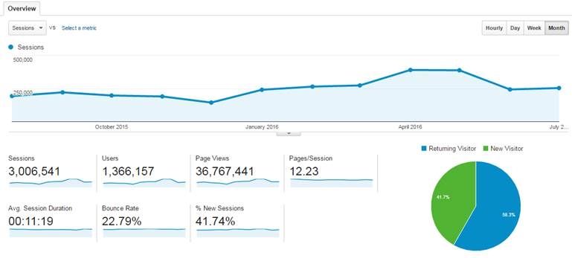

**Web sessions with MPO registration**

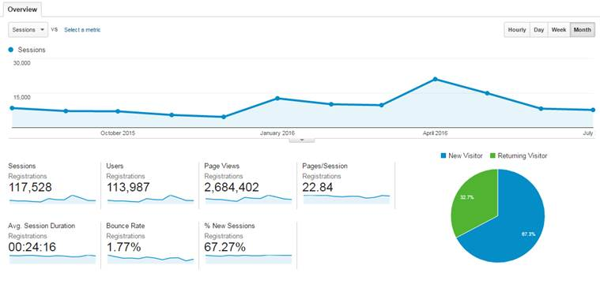

The scheme now has over 2,049 Twitter followers (457 additions in the quarter representing an increase of over 28%) and 2,526 Facebook ‘friends’, which is an increase of 2,135 in the quarter. These increases predominantly from a paid media campaign delivered as part of the agreed communication plan. There has also been an increased level of interest in communications through LinkedIn, which now has 301 registered followers. This is anticipated to increase as a bespoke programme of messaging will be introduced for this forum from August.

Twelve employer seminars (224 registrations) and 18 webinars (293 registrations) focussing on MDC were successfully delivered in the last quarter.

Work to develop the website is continuing in line with the agreed plan. A dummy environment has been set up to replicate the website to allow testing of the revised structure, format and content before being promoted into the live site from January. As this is a development of the existing site rather than a new product, updates will be phased so as to moderate the impact on the user, and highlight the improved usability and content.

As part of the website development work, user experience focus groups with employer and employee user representatives have been delivered across the quarter to gain a better understanding of: strengths and weaknesses in the current format; user’s views and priorities; and any key content that needed to be promoted. As well as providing constructive input to the revised website, the comments and feedback will also help inform the development of the scheme engagement plan for 2017.

|  |  |
| --- | --- |
| **Forward look** |  |

There will be a meeting in late August between Teachers’ Pension and the Department’s academies team to define and develop clear communications links to help identify the throughput of new academies to allow early engagement by the scheme.

Work will continue on the scheme’s submission to the Department’s marketing team for clearance of the Marketing Exemption application. The exemption is to meet the requirements of government wide restrictions on spend related communications.

The next TPARG meeting will take place in London on 3 October.