**Engagement August – October 2015**

Quarterly update

Kerry Tate-Maskill has been appointed as the new Teachers’ Pensions ‘Head of Engagement’, taking up post in October. She replaces Claire Boston-Smithson, who has now left TP. As a driven and creative Communications, PR & Marketing professional, Kerry brings with her a wealth of experience from both the public and private sectors.

The TPS communications strategy for the current contract year was approved in September. This included Marketing Exemption for 8 promoted posts (a facility to promote TPS information, news and events on users’ Facebook or website news feeds) for social media campaigns delivered across the year. These will be targeted at key points across the year when teachers are likely to be thinking about their pensions, for example, the New Year, the end of the financial year and the beginning of a school term. Reporting arrangements are under discussion with Department campaign managers and will be provided monthly. Output from this will also feed into future quarterly reports for the Board.

Understanding the social media landscape as a key engagement tool has continued to develop during the quarter. TP’s Engagement Team continue to monitor social media interaction and is instantly alerted of any tweet, Facebook posting or comment on YouTube. The benefit of this was amply demonstrated in resolving some particularly negative feedback (which had gained a groundswell of interest) from the relative of one scheme member about the service they had received. This has led to the development of standardised ‘social media guidance’, the principles from which will be applied when dealing with future instances.

|  |  |
| --- | --- |
| **Member engagement and Campaigns** |  |

TP have continued to see a steady reduction in website interest when compared to the same period last year, although the total number of visits remains healthy at 2.58 million since the beginning of the calendar year.

This drop when compared to last year is almost certainly the corollary of a spike in interest in 2014 as part of the build up to the implementation of scheme Reform. The fall in numbers is not a cause for particular concern, particularly as there continues to be a steady increase in social media interaction, suggesting retention of membership engagement, but via alternative means.

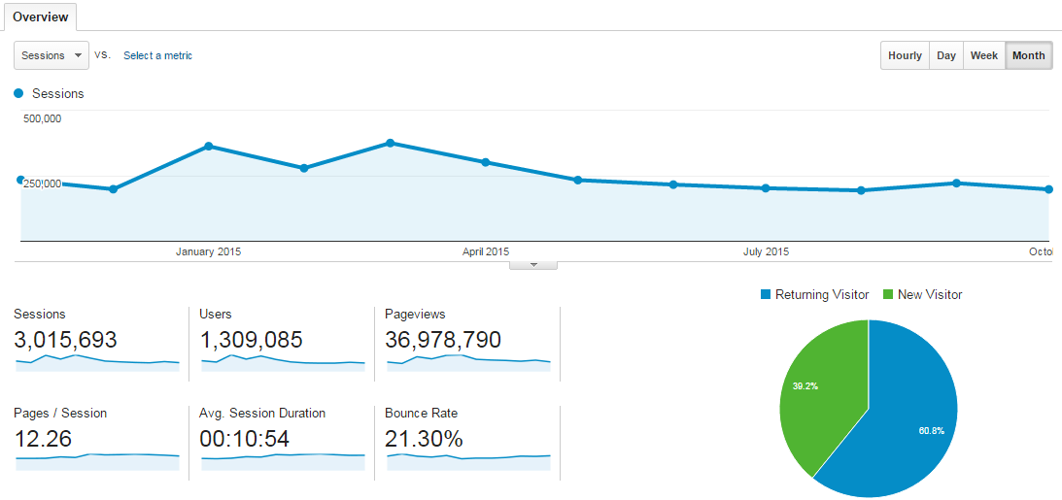

**Sessions from November 1 2014 – October 31 2015**

This report is based on 498,251 sessions (16.52% of sessions).

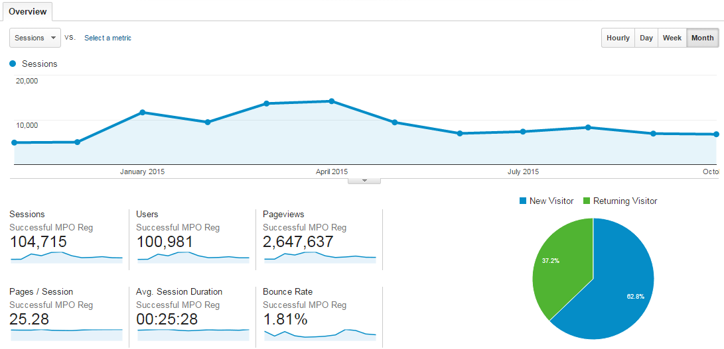

**MPO Registrations from November 1 2014 – October 31 2015 (Number of sessions is the one to focus on, page views looks like an anomaly)**

This report is based on 498,251 sessions (16.52% of sessions).

Campaign activity, and in particular the use of sponsored posts in October following the approval of the marketing exemption, has driven a slow but steady increase in social media traffic in the last quarter which is also filtering through to the continued increase in MPO accounts (86 in October). The scheme now has over 1,200 Twitter followers and 79 ‘likes’ on Facebook – an increase of over 50% in October.

This is further supported by the continued increase in members setting up My Pension Online (MPO) accounts, with 377k members now registered – an increase of 27k in the current quarter.

Stakeholder engagement groups (TPARG/TPAF) met in early October and were well supported; the Chair of TPSPB attending the TPAF event to deliver a summary of the Board’s roles and responsibilities.

|  |  |
| --- | --- |
| **Employer engagement and Campaigns** |  |

The first phase of the targeted campaign to engage multi academy trusts was successfully implemented at the end of September, and has exceeded the anticipated open and ‘click through’ rates. The second phase of this campaign will be delivered in November.

The ‘New employer welcome email’ - particularly pertinent during September and October, when the majority of new academies open – has also exceeded its targets this quarter.

TP’s finance team attended the October LGA conferences in York and London to deliver an overview of their work, which was positively received. Feedback from the sessions will be considered in delivering future service improvements.

The LGA conferences were also used as an opportunity to stimulate interest in employers in a new campaign to gather member email details, to improve scheme contact data. Take up has been limited to five employers initially.

The design of the Annual Benefit Statement to include a breakdown of final salary and career average arrangements has now been signed off and is at IT development stage. Initial low level communications have been delivered through the Employer Bulletin and the website. Further communications will be delivered in November.

New guidance for both Lifetime Allowance and Annual Allowance (AA) has been drafted, covering the topics from a basic introduction to more detailed technical information, e.g. information about the tapered AA with effect from April 2016. These will be posted to a new taxation section which is being set up on the TPS website.

The guidance has been reviewed by the TP technical team and is currently being considered by the Engagement team to ensure it is correctly branded and member friendly. The aim is to have the documents finalised, with a new taxation section of the website set-up, by the end of November.

|  |  |
| --- | --- |
| **Seminars/Webinars** |  |

Only 7 employee seminars (126 registrations) and 26 webinars (167 registrations) were delivered in the last quarter. Seminars were deferred until the second week in September to take account of a lack of interest during the school holiday period, however there has also been a wider dip in demand for places.

The delivery of future webinars is currently under consideration. As seven proposed events had to be cancelled in October due to lack of interest, the number of November and December events will be rationalised with a view to improving attendance. The development of video material – which will be made available through the TPS website and other social media channels from the end of December – will see a further reduction in webinars in future as videos will provide learning opportunities on similar topics in a more accessible and flexible way for members and employers.

|  |  |
| --- | --- |
| **Forward look** |  |

Two member campaigns will be delivered in November for ‘Planning your Winter Break’ (Options Explorer, engaged members only) and Re-Employment (Retired members). Automated communications and dormancy campaigns will also be delivered.

Social media sponsored posts will continue, after the review of activity suggested delivering the posts over a longer period but concentrating on bespoke sites (which is providing better results). This, along with continuous social media messaging should continue to increase TP Twitter and Facebook followers.

As well as the employer bulletin, employer campaigns will continue to be delivered advising members of the new flexibilities. The ‘capture of member emails’ campaign has attracted interest through the Employer bulletin and will be repeated with these employers, and TP will look to extend this to a wider cohort of employers. The second phase of the Multi Academy Trusts campaign will also be delivered in November. Web developments will include testing of the new online repayments form and the continued development of the flexibilities calculator. Another item in development includes the Flex Form & Modeller which is expected to go live in spring 2016. This is an eagerly anticipated development which will provide a more accurate estimate of the costs and benefits of the different options. The improved web form will be integrated in the modeller to allow members to apply for these flexibilities online.

Finally, in development for delivery in the next quarter are the ‘check your details if no update in 12 months’ campaign - a reminder to re-engage members who have not accessed their details during this period - and a revised ‘transfer in’ web form, which is currently under IT review.